Experiment No: 6

Implementing encryption algorithms
ET3272: Computer Network and Security

Name of the student: Mandar Chinnapurkar Roll No.: 18
Div: ET- B Batch: 1
Date of performance:

Theory:

Network traffic analysis is an essential task in understanding how data flows across a network and identifying potential issues or security risks. Packet capturing tools like Wireshark are widely used to monitor and analyze network traffic in real-time, allowing network administrators and cybersecurity professionals to examine individual data packets, understand their structure, and study how various network protocols work.

Wireshark is a network protocol analyzer that captures packets on a network interface and displays detailed information about them, including source and destination IP addresses, packet sizes, protocol types, and more. By inspecting captured packets, users can understand how protocols like TCP/IP, HTTP, DNS, and others behave during data transmission, enabling them to diagnose network issues, optimize performance, or identify malicious activities.

Wireshark supports a variety of protocols, including:

- TCP/IP (Transmission Control Protocol/Internet Protocol): A core set of protocols for transmitting data over the internet.
- HTTP (Hypertext Transfer Protocol): Used for transmitting web pages and web content.
- DNS (Domain Name System): Resolves domain names into IP addresses, enabling data routing on the internet.
- ARP (Address Resolution Protocol): Maps IP addresses to MAC addresses for communication within a local network.

Packet capturing involves intercepting and logging packets transmitted over a network. Each packet contains a header and a payload. The header includes important metadata, such as the protocol being used, packet size, source/destination addresses, and other control information. The payload contains the actual data being transferred.

Procedure:

Install Wireshark:

- Download and install Wireshark on your system from wireshark.org.
- Ensure you have the necessary permissions to capture packets on your network interface.

Capture Network Traffic:

- Open Wireshark and select the network interface you wish to capture packets from (e.g., Ethernet, Wi-Fi).
- Click on the "Start" button to begin capturing network traffic in real-time.

Filter Specific Protocols:

- To filter specific protocols, enter the protocol name in the filter bar (e.g., tcp to display TCP packets, http for HTTP, or dns for DNS packets).

Capture and Analyze Traffic:

- Perform activities that generate network traffic. For example:
- Open a web browser and visit a website to generate HTTP traffic.
- Ping a website to see ICMP traffic.
- Use any network application to trigger data exchanges.
- Stop the capture after collecting enough data by clicking the "Stop" button.
- Analyze individual packets by clicking on them to view details like source and destination addresses, the protocol in use, packet flags, and other metadata.

Understand Network Protocols:

- For each packet, Wireshark breaks down the header and payload for closer inspection.
- Examine the structure of a TCP packet: the source/destination ports, sequence numbers, acknowledgment numbers, and flags (SYN, ACK, etc.).
- For HTTP packets, examine request types (GET, POST), response codes (200 OK, 404 Not Found), and payload content.
- DNS packets can be used to study domain name resolution by observing requests and responses for domain names and IP addresses.

Save and Export Results:

- Save the captured data as a .pcap file for future analysis or reporting.

- Wireshark also allows you to export specific packet details or summaries as text files or CSV files for further processing.

Result:

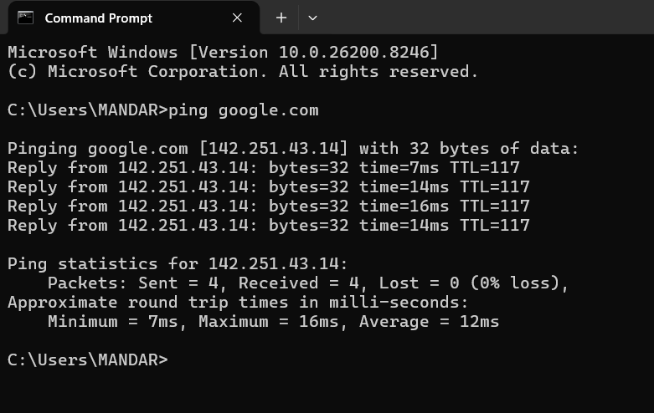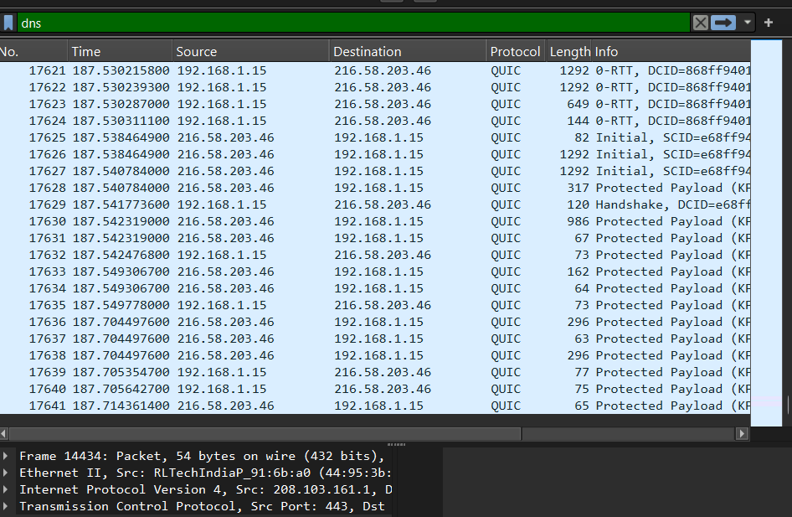

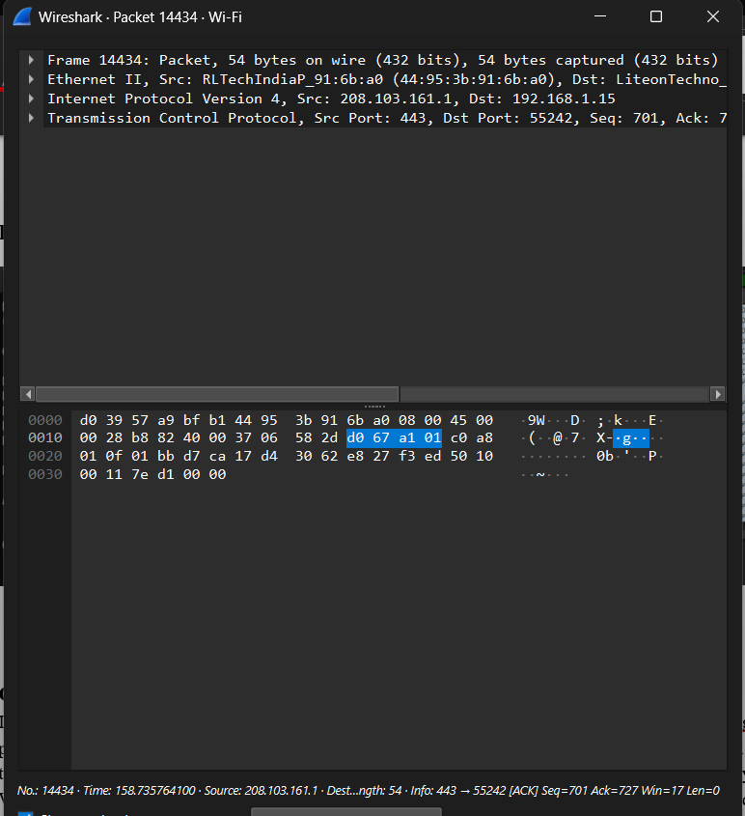

Conclusion:
In this lab, we effectively captured and examined network traffic using Wireshark. By analyzing protocols such as TCP/IP, HTTP, and DNS, we developed a clear understanding of how data is transmitted and routed within a network. The detailed packet-level information provided by Wireshark helped us explore the functioning of network protocols, identify performance-related issues, and detect possible security concerns.

